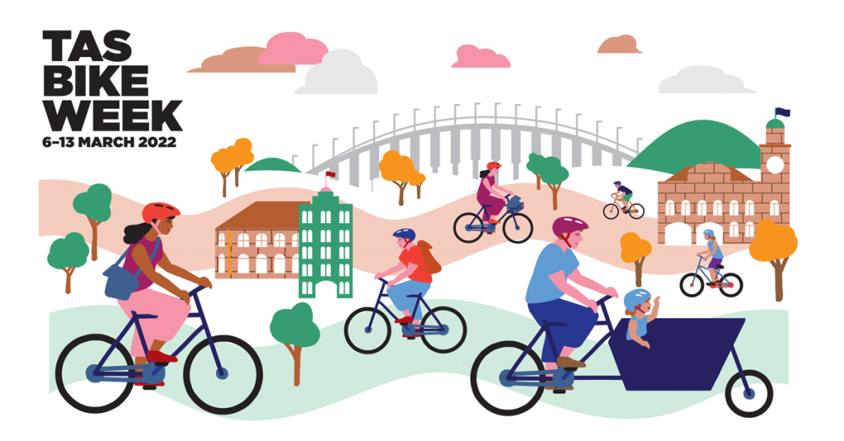
Sunday 6 March
- Kunanyi Challenge ride – Hobart Wheelers/Dirt Devils Cycling Club. 7 am, Longley International Hotel. Tickets $35 for adults and $15 for juniors, must book before 24 February:
- Women on Wheels ride – Bicycle Network, 10 am – 12 pm, Cornelian Bay upper car park, 14.5 km, Intercity Cycleway ride to view the Corridor of Modern Art street murals. Free
- Hobart Bike Kitchen – 130 Davey Street Hobart, 1–4 pm. Come along to learn how to build and look after your bike. Free.
- Flinders Island Lions Club Le Tour de Flinders – to be confirmed.
- Okines Bike Shed – Okines Community House, 10 am – 1 pm, 540 Old Forcett Road, Dodges Ferry. Learn to repair your bike, parts available. Free.
Monday 7 March
- Margate to Coningham return – Bicycle Network, 9.30 am – 12.30 pm, 22.5 km, meet Dru Point in Margate, off-road bush paths, new cycleway, footpaths and quiet roads. Free.
- Okines Bike Shed – Okines Community House, 11 am – 3 pm, 540 Old Forcett Road, Dodges Ferry. Learn to repair your bike, parts available. Free.
Tuesday 8 March
- International Women’s Day solo ride – Global ride organised out of the US, you choose where and when your ride but please share it on the global Facebook site: http://www.facebook.com/groups/2587066751413662
- Bike Polo Match for newer players – Hobart Bike Polo, Unigym outdoor courts in Sandy Bay, 5.30-7.30, contact tuuhbpc@gmail.com, $10 one-off price, $5 for regular players. Double vaccination required.
Wednesday 9 March
- TBUG Westbury to Hoggs Lane – 9.15 am, 34 km, meet Franklin St sport ground Westbury, quiet country roads loop. Free.
Thursday 10 March
- Bike Polo match for experienced players – Hobart Bike Polo, Unigym outdoor courts in Sandy Bay, 5.30-7.30, contact tuuhbpc@gmail.com, $10 one-off price, $5 for regular players. Double vaccination required.
- E-bike Coffee Cruise City and Nature – Bicycle Network, 9.30 am–11 am, meet at Brooke Street Pier, 8.9 km, Hobart Rivulet Path and city streets. Free
- TBUG Twilight Trails around Launceston ride – Meet 5.45 am, Park Street Royal Park, 10 km. Free
- Okines Bike Shed – Okines Community House, 11 am – 3 pm, 540 Old Forcett Road, Dodges Ferry. Learn to repair your bike, parts available. Free.
Friday 11 March
- Brave the Bridge – Bicycle Network, 8 am – 12 noon, meet at Cornelian Bay upper car park, 21.8 km, ferry, cycleways and Tasman Bridge. Free.
- TBUG History Ride – TBUG, 10 am – 12 pm, meet at Park Street, Royal Park, 10.7 km, off-road paths and quiet roads through Inveresk and Invermay.
- KBUG Kettering Loop – KBUG, 9.30 am, meet at Sea Wall Cafe, Kettering, 9 km, easy, scenic loop, riding on Channel Hwy and gravel Manuka Road. Free.
Saturday 12 March
- Light up Launnie – TBUG, meet at QVMAG Inveresk car park for 10 km ride on city streets and trails. Light up your bike and yourself. Free
- Pawleena Penna Circuits – Bicycle Network, 10 am – 12 noon, meet in Sorell, 30 km, mix of quiet roads and bike paths.
Sunday 13 March
- New This, New That, New the Other – Bicycle Network, 11 am, leaving from Latrobe, 33 km, all on pathway to new Don River Bridge.

