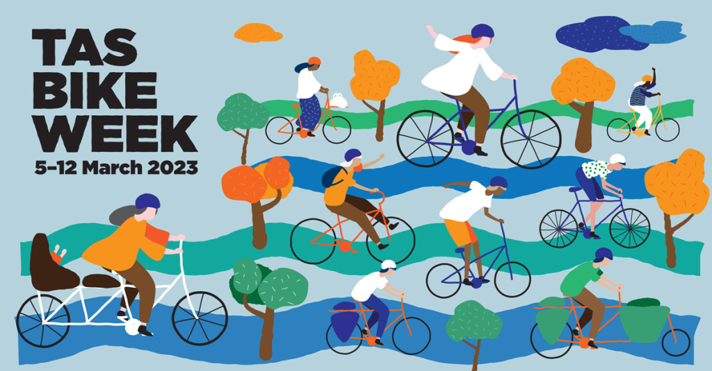
Sunday 5 March
- Hobart Bike Kitchen – 130 Davey Street Hobart, 1–4 pm. Come along to learn how to build and look after your bike. Free.
- Retro Bike Showcase and Ride – TBUG, Village Green, Latour Street, Longford, 10 am – 2 pm. BYO classic bike, lunch and chair and dress to impress in period cycling attire. Prize for best restored/maintained bike: $100 gift voucher
- Hobart screening of the US film MOTHERLOAD! all about cargo bikes and how they can change the way we get around, South Hobart Sustainable Community, 3 pm, Wide Angle Tasmania, 6 Washington Street, South Hobart, free.
- Launceston screening of the US film MOTHERLOAD!, TBUG, 7 pm, Raymond Ferrall Centre at the Newnham Campus, free. Ride from Royal Park to the screening will leave at 6 pm.
- Pipeline Track from Fern Tree or Hamlet – Bicycle Network free social ride, 10 am – 2 pm, meet at Fern Tree Tavern car park
- Back on your Bike beginner MTB sessions. If you know how to ride a bike but have no idea about mountain biking this is a good taste of riding on beginner trails before you go on to skills session training. Queens Domain. 4.30–6 pm. Free but please RSVP.
- Back on your Bike sessions at Okines Bike Shed, 10am – 11.30am, 12pm – 1.30pm. 540 Old Forcett Road, Dodges Ferry. Free but please RSVP.
Monday 6 March
- Okines Bike Shed – Okines Community House, 11 am – 3 pm, 540 Old Forcett Road, Dodges Ferry. Learn to repair your bike, parts available. Free.
- TBUG Bike Maintenance and pizza – Riverbend Park, 81 Lindsay Street, Invermay, 6 pm. Free discussion with The Bike Guy and pizza – RSVP for catering.
Tuesday 7 March
- Bike Polo Match for newer players – Hobart Bike Polo, Unigym outdoor courts in Sandy Bay, 5.30–7.30, contact tuuhbpc@gmail.com, $10 one-off price, $5 for regular players. Double vaccination required.
- Super Tuesday annual commuter count – Bicycle Network, Launceston Council, Devonport Council. Register online for Hobart count.
Wednesday 8 March
- TBUG Wednesday ride – Hazelbrae to Bracknell, 42 km, 9.15 am – 1 pm. Free.
- International Womens Day ride – TBUG, 5.45 pm, Silos car park Tamar River side. A supportive ride to the Tailrace and back for fruit punch and talk from the Women’s Legal Service. Wear green and purple. Free
- International Womens Day ride – Bicycle Network, RSVP direct to ride leader Di, Sandy Bay to Taroona ride.
- Back on your Bike Lunchtime Skills Refresher session 12–1 pm and After Work Group Ride 5.15–6 pm. Free but please RSVP.
Thursday 9 March
- Bike Polo match for experienced players – Hobart Bike Polo, Unigym outdoor courts in Sandy Bay, 5.30–7.30, contact tuuhbpc@gmail.com, $10 one-off price, $5 for regular players.
- Okines Bike Shed – Okines Community House, 11 am – 3 pm, 540 Old Forcett Road, Dodges Ferry. Learn to repair your bike, parts available. Free.
- TBUG Thursday night ride – Meet at 5.45 pm at the Park St entrance to Royal Park. 10–15 km. Free
- Ranelagh River Ride – Bicycle Network, 9.45 am – 12.30 pm, 26.7 km on bitumen and gravel roads, leaving from Summer Kitchen Bakery. Free.
- Back on your Bike sessions at the South Hobart Rivulet. 10–11.30 am and 12–1.30 pm. Free but please RSVP.
Friday 10 March
- History Ride – TBUG, 9.45 am, Silo Hotel car park to Ravenswood Bike Museum. Lunch back at the Silos. Free.
- River to Mountain: Friday Bike Week pub lunch – Bicycle Network, 10.30 am, Meet at upper car park at Cornelian Bay. Free.
- Back on your Bike session at Howrah, 10–11.30 am. Free but please RSVP.
Saturday 11 March
- Night Ride – TBUG, 7 pm. More details to come. Free. Prize for best decorated bike: $100 gift voucher from Roll Cycles.
- Bromptons Bike Week Rally – Bicycle Network, 9.45 am, McVilly Drive car park, ride to Mona along the Intercity Cycleway. Free
- Back on your Bike social ride along the Intercity Cycleway for anyone whose been to a skills session, 10 am – 12 pm. Free but please RSVP.
Sunday 12 March
- Community Bike ride – TBUG, 11 am, Royal Park. Free. Followed by pedal powered smoothies and BYO lunch afterwards.
- Back on your Bike session at Royal Park before the community ride, 10–11 am. Free but please RSVP.

