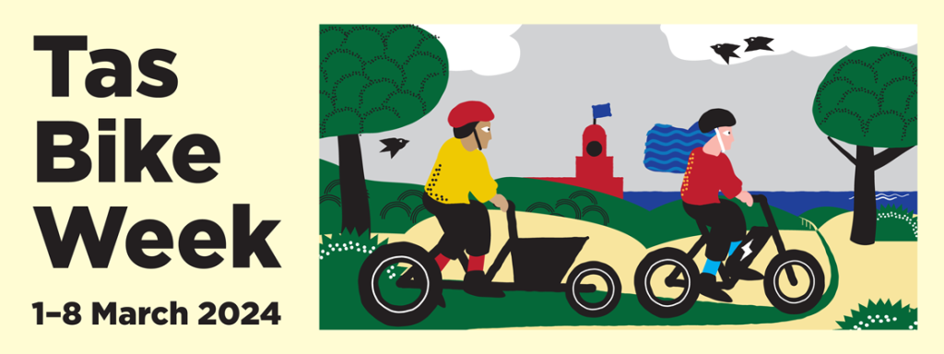
Friday 1 March
- Coffee, Chats and Cycles – Jampacked Cafe, Hunter St, Hobart, 11.30 am – 12.30 pm. Come along to meet other bike riders and talk all things cycling. Pay for what you order.
- Queens View social ride – Brooke Street Pier, Hobart, 10.15 am. Meet ride leader Di for a 12km discovery of the different cycling options on the Queens Domain. Heading to Coffee, Chats and Cycles after the ride. Free.
- Launceston History Ride - 9.45am-12.30pm. Leaving from the Riverbend car park and heading to Newstead to tour historic buildings. Free
Saturday 2 March
- Flight of the Folders - 10am-1pm. Ride out to MONA on folding bikes. Free.
- Light up Launnie night Ride - 7-9pm. Meet Di at QVMAG Inveresk car park for 7.30pm departure. $100 Roll voucher for best decorated bike. Free
Sunday 3 March
- kunanyi Challenge time trail to the summit. Meet at Longley Hotel. 7am. $35 plus racing licence.
- Launceston Retro Ride - 10.30am-12 noon. Meet at Princes Square for 10km ride. $100 Roll voucher for best restored bicycle and retro clothing.
- Elderslie Dysart Loop social ride – 10am-2pm. Broadmarsh. Country gravel backroads ride.
Monday 4 March
- Okines Bike Shed – Okines Community House, 11 am – 3 pm, 540 Old Forcett Road, Dodges Ferry. Learn to repair your bike, parts available. Free.
Tuesday 5 March
- Super Tuesday annual commuter count – Bicycle Network, Launceston Council, Devonport Council. Register online for Hobart count.
- Bike Polo Match for newer players – Hobart Bike Polo, Unigym outdoor courts in Sandy Bay, 5.30–7.30, contact tuuhbpc@gmail.com, $10 one-off price, $5 for regular players.
Wednesday 6 March
- TBUG Gravelly Beach to Rowella – meet 9.15am at Gravelly Beach boat ramp car park for the 40-46km route riding at about 20-25km/h. Free
Thursday 7 March
- Okines Bike Shed – Okines Community House, 11 am – 3 pm, 540 Old Forcett Road, Dodges Ferry. Learn to repair your bike, parts available. Free.
- TBUG Bike Week Twilight Ride - meet at 5.45pm at Royal Park. Leisurely 10-15km ride around Launceston trails. Free.
Friday 8 March
- Margate to Coningham return - 9.30am-12.45pm. Meet at Dru Point car park. Free.
- Hobart International Womens Day social ride - 10am-12pm. Cornelian Bay, New Town. Celebrating the Together We Ride sisterhood, come to MONA for coffees and chats. Free.
- Launceston International Womens Day ride - 9.45am-12 noon, leaving from Riverbend Park car park. Dress in purple, white and green for the $100 Roll voucher for best dressed. 23km, medium pace.

